**ASSAULT IN DIVISION 51**

Audience: Chair of Toronto Police Service Board

Yash Umesh Phalke

**Graph Analysis**

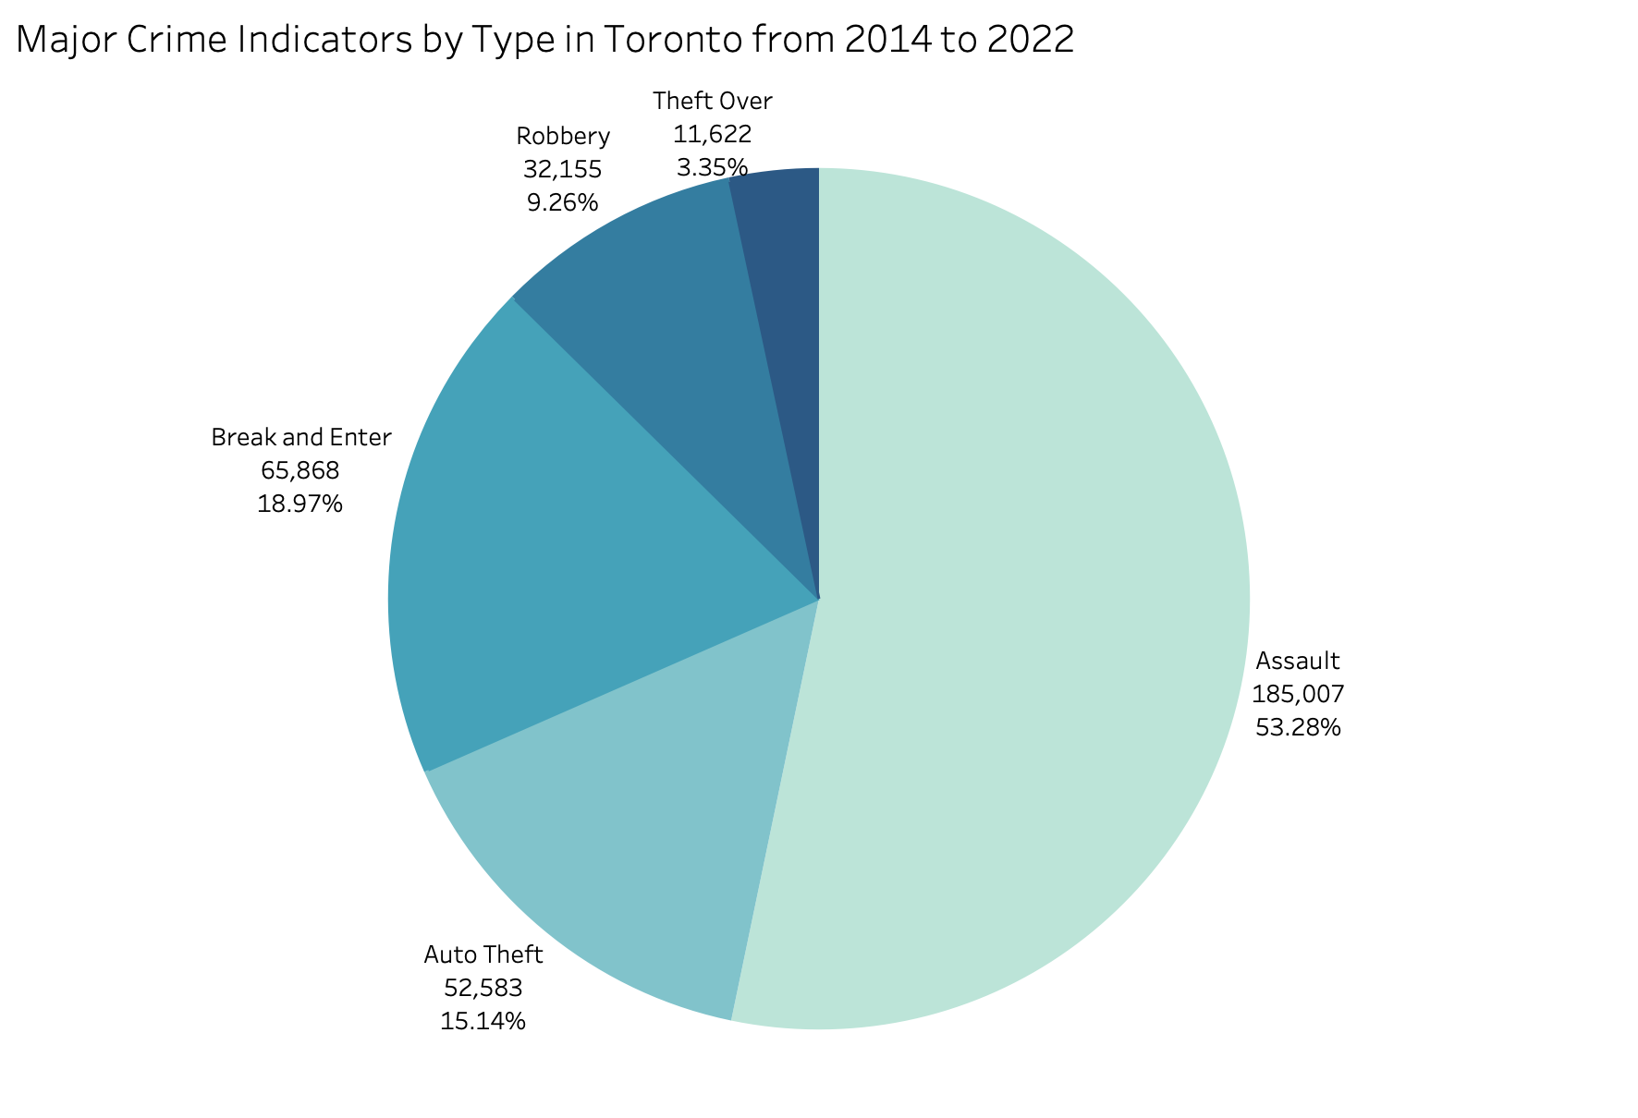

The pie chart presents a comprehensive view of major crime indicators in Toronto from 2014 to 2022 which are auto theft, assault, break and enter, robbery and theft over. Assault has been the most occurring among all 5 major crimes holding 53.28%, translating to 185,007 incidents over the years and the least occurring is theft over referring to high-value thefts is 3.35% and the rest lies under 20%. Therefore, it can be understood that assault appears to be the most pressing issue.

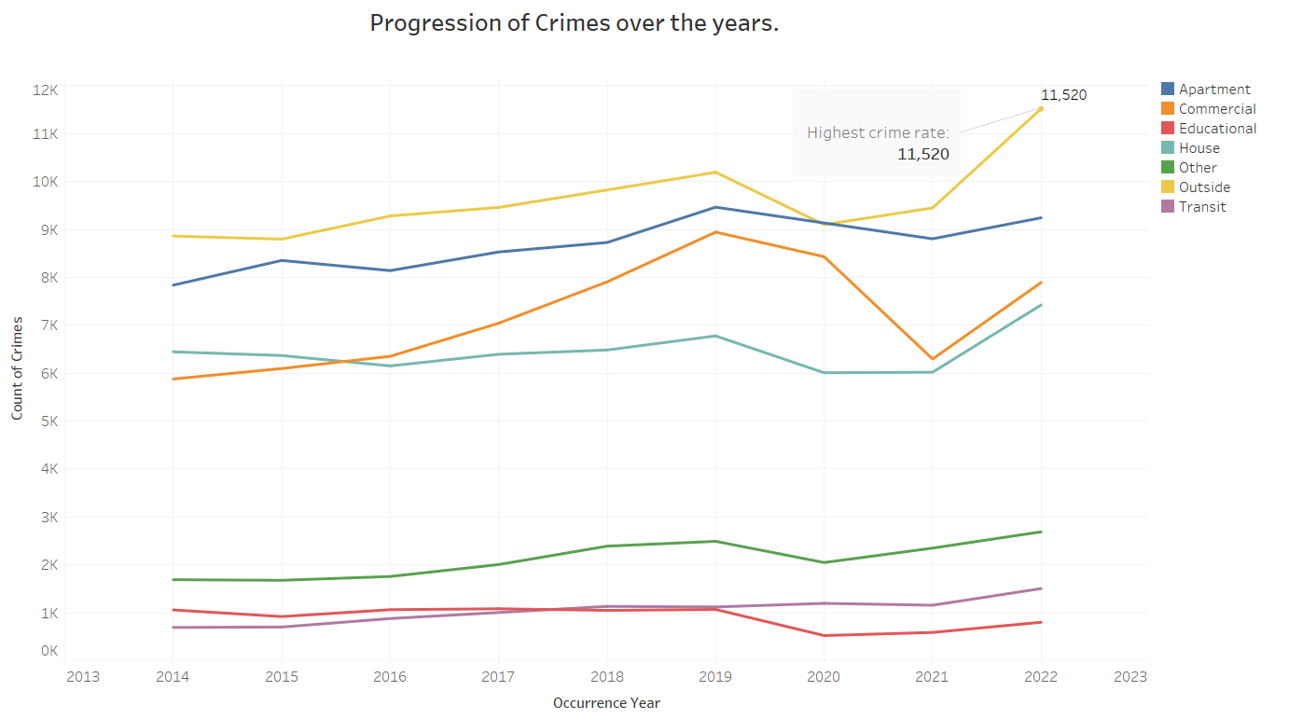

While examining the increment of assault we found that overall crime has increased especially after the pandemic. This line chart tracks the progression of crimes across various locations over several years. The trend lines indicate fluctuations over the years, with a general increase in crime rates in most categories. However, the location with the highest crime rate is 'Outside', with a peak at 11,520 incidents which means that the public areas are hotspots for such criminal activity. This emphasizes on the areas where the police and the community can take preventive measures such as increasing surveillance and patrolling, especially on violent crimes like assault and other crimes that take place outside.

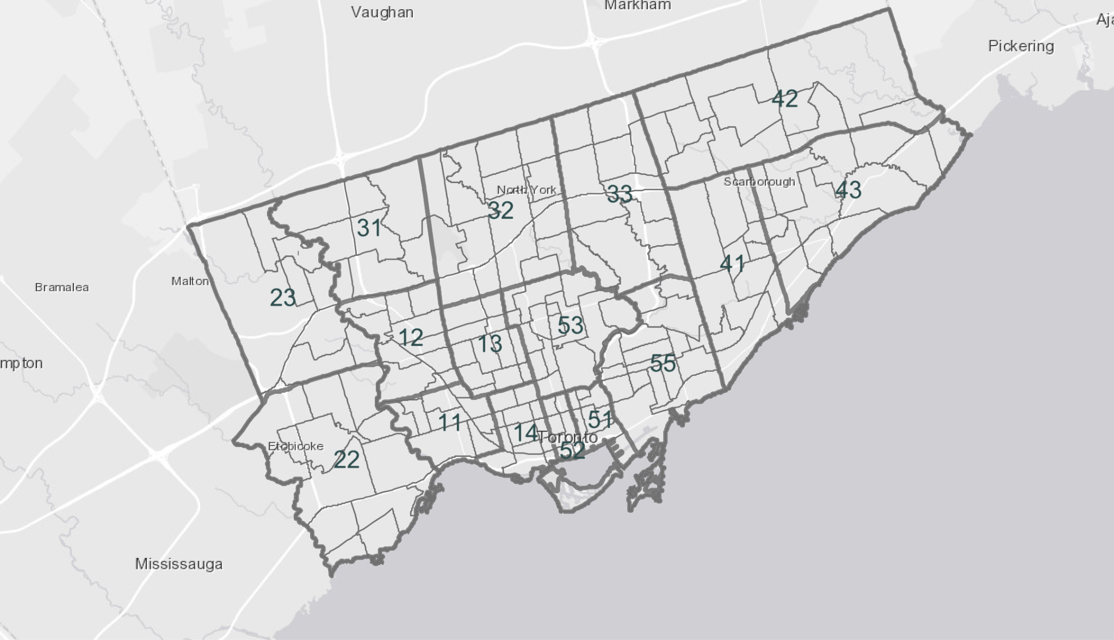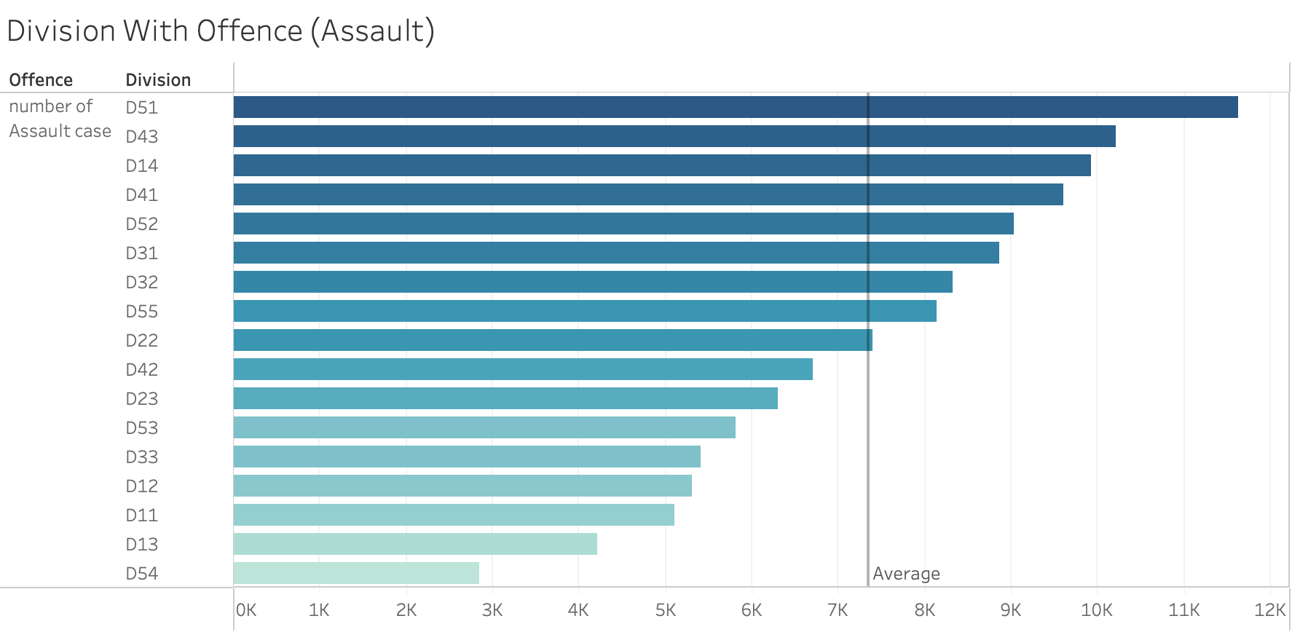

Delving deeper into the situation, we compared the count of assault cases across different divisions and we discovered that the Division 51 of Toronto has been an epicenter for assault. This indicates that the authorities need to address the high incidence of assault in the area and perhaps, review their current patrolling strategies to control the assault cases and even other crimes in this division.

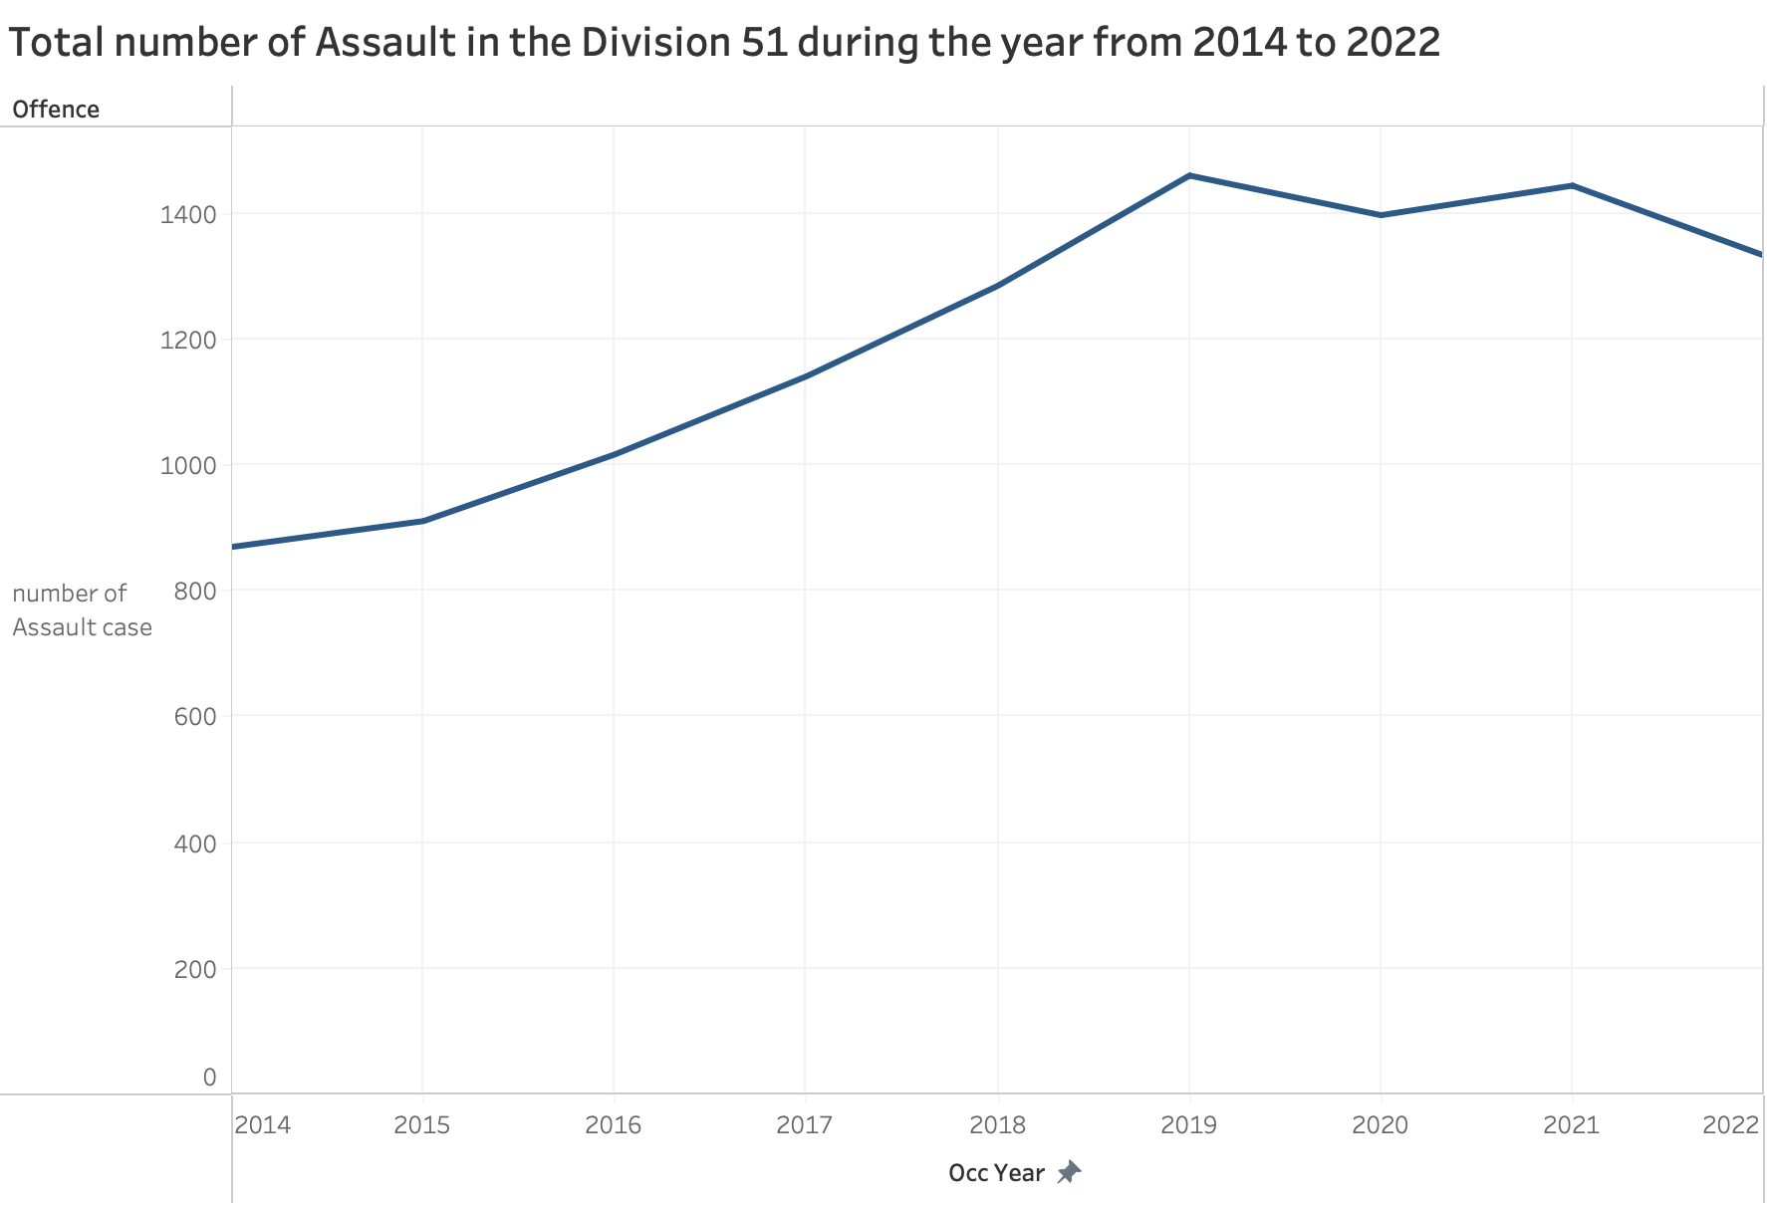

This line chart is a year-by-year breakdown of assault cases specifically in Division 51. There's a visible upward trend in assault cases from 2014, reaching its highest point in 2019. Although there is a slight dip after 2019 possibly because of the pandemic however, the number of cases still remains relatively high as compared to the starting point in 2014. This data might indicate the effectiveness of crime prevention, increase in population, police resourcing or changes in reporting practices over time.

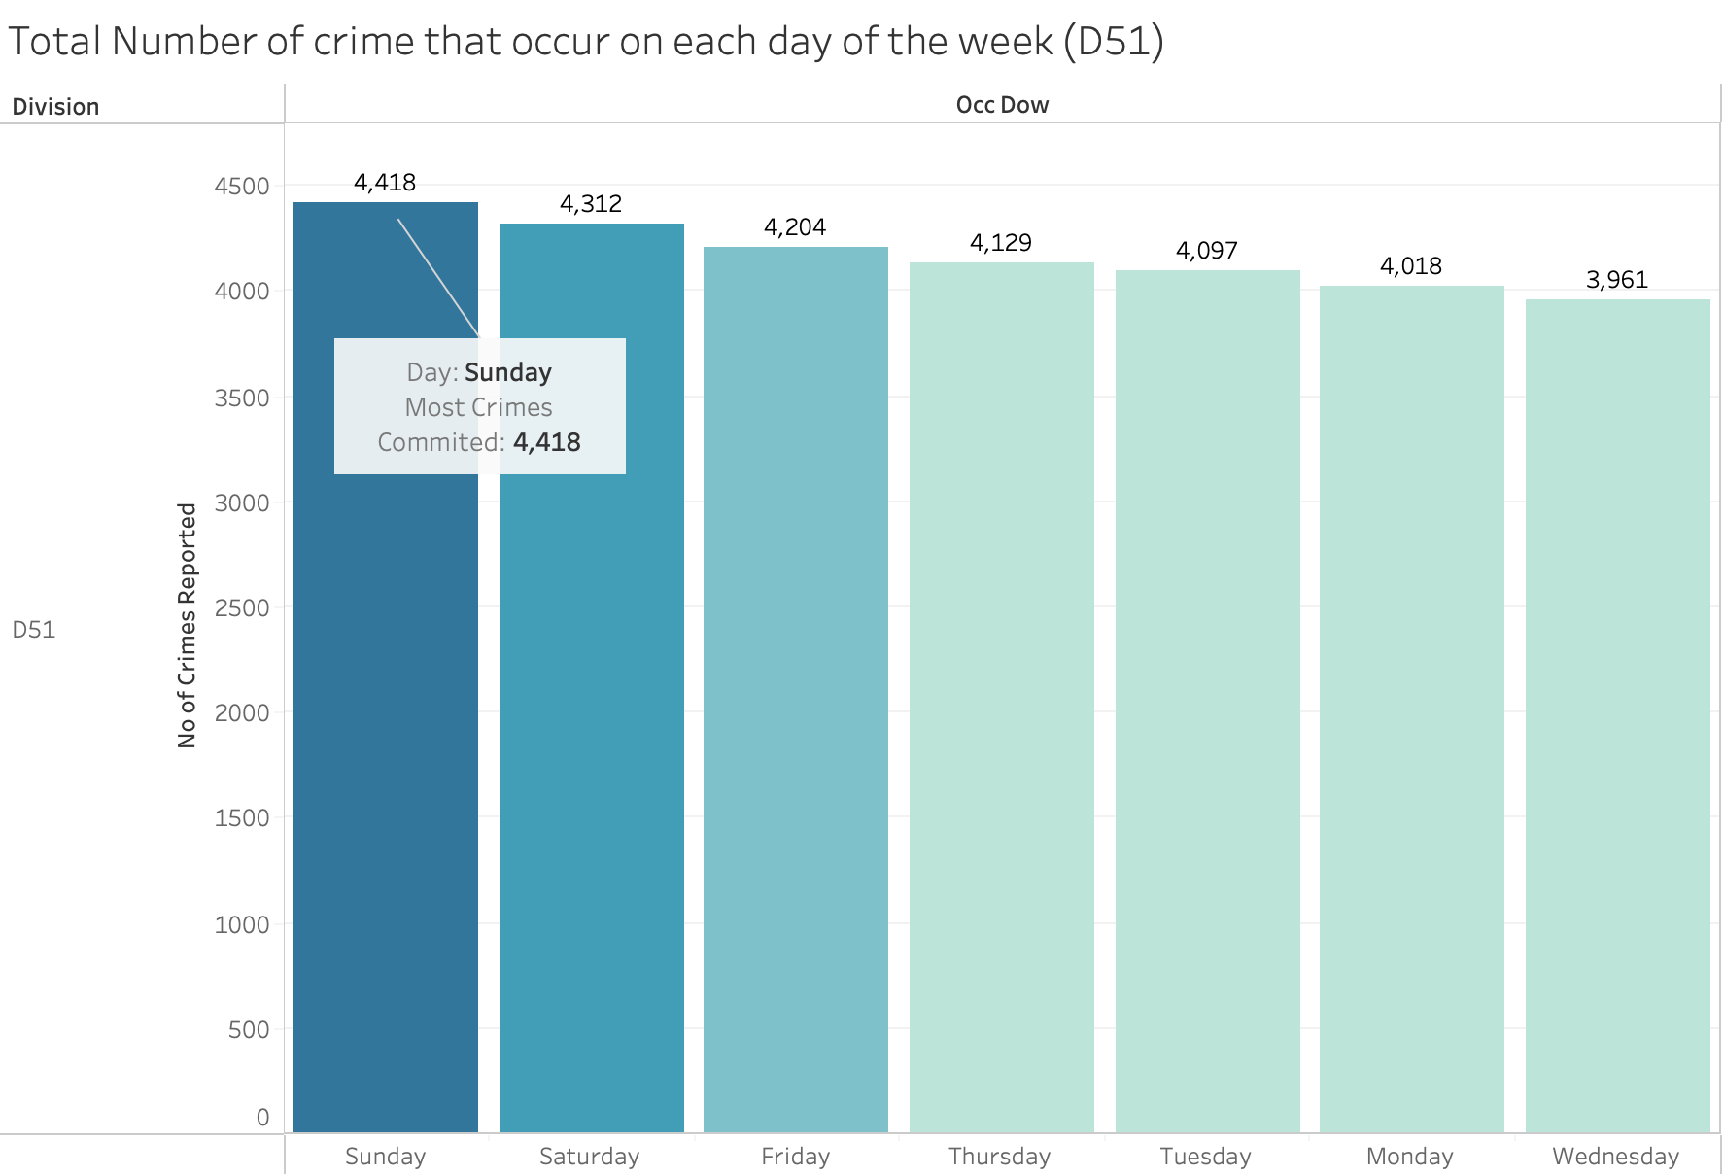

A close examination of crime patterns in Toronto's Division 51 from 2014 to 2022 reveals that crimes tend to spike on Sundays, with a total of 4,418 incidents making it the day with the most reported crimes. This uptick could be linked to a variety of factors. Typically, Sundays round off the weekend, a time when social events are commonplace, potentially giving rise to more opportunities for crime.

As the new week begins, there's a notable downtick in the number of crimes. Saturdays and Fridays also see a high number of incidents. This suggests that there's something about the weekend – perhaps the mix of leisure activities and the increased number of people out and about – that correlates with a higher likelihood of crime.

By the time Wednesday rolls around, crime reports drop to their lowest, with 3,961 incidents. This midweek dip may be due to a drop in social activities and nightlife, as routines settle back into the workweek norm. This pattern is more valuable information for the police. It suggests that deploying more officers and engaging with the community over the weekend could be an effective way to prevent crime when it's most likely to occur.

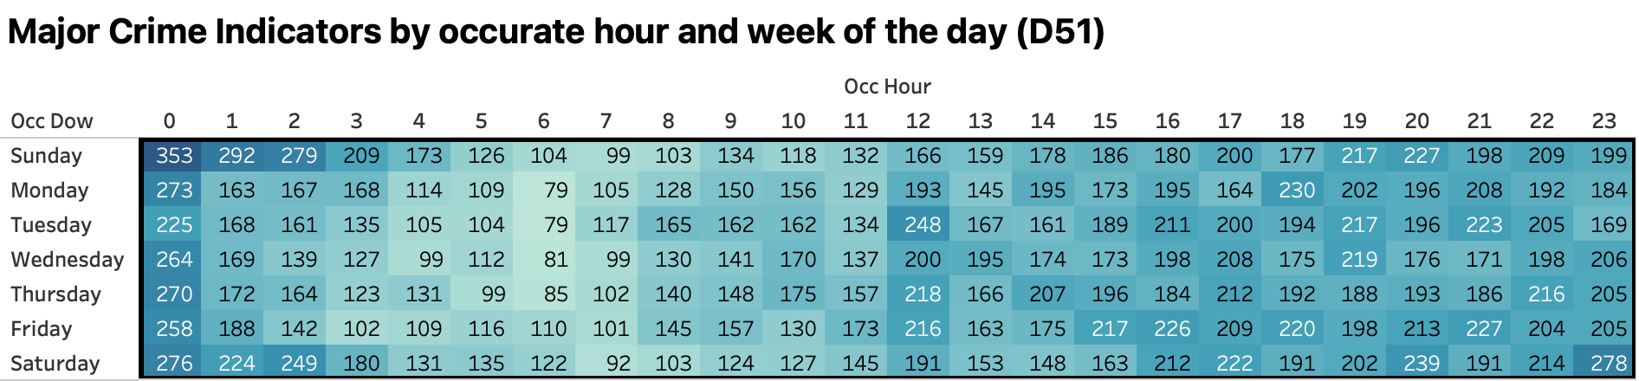

The breakdown of crimes by hour, as shown in the heatmap, casts a spotlight on the times when crime is most likely to happen. This graphical representation, with its color-coded intensity levels, highlights an increase in criminal activity as the day turns to evening, peaking as the night deepens. Taking Sunday as an example, there's a notable uptick in crime beginning late afternoon, with incidents hitting their highest between 11p.m and 12a.m This pattern holds true for Saturdays as well, with these late hours standing out as the most common time for crime within the entire week, reaching up to 278 reported incidents at 11 p.m.

This pattern points to a trend of crimes being more frequent at night. These findings are invaluable for those tasked with keeping our streets safe, implying that steps like ramping up police patrols, improving street lighting, and fostering a vigilant community might be most effective during these identified peak times. Sharing this information with the public can also empower residents, encouraging them to be more cautious during these higher-risk hours and to play a role in ensuring their own safety and that of their neighbors.

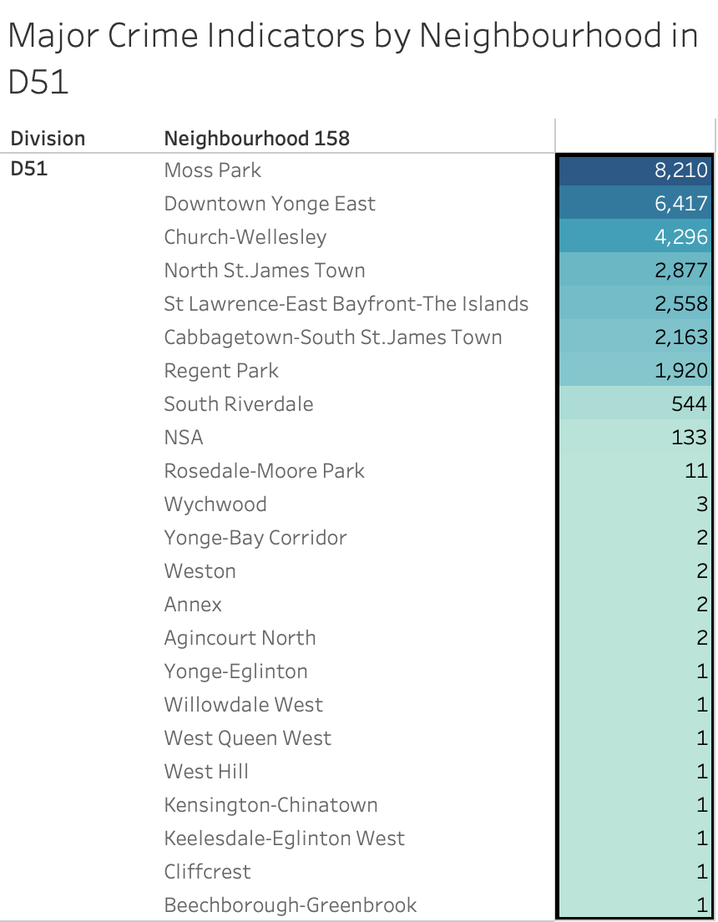

Deep down into the neighborhood-level crime statistics in Division 51 which uncovers a dramatic variation in the number of reported incidents. Moss Park emerges as the area most impacted by crime, with a staggering 8,210 reports throughout 2014 to 2022. This high figure is more than a mere number; it represents the day-to-day challenges faced by the people living there, highlighting an urgent call for tailored strategies to combat crime.

In stark contrast, neighborhoods like Downtown Yonge East and Church-Wellesley, with 6,417 and 4,296 reported crimes respectively, seem almost tranquil. This significant difference in crime rates points to underlying factors affecting neighborhood safety – factors that could range from economic conditions to the effectiveness of local law enforcement.

The situation becomes even more pronounced when you look at places like Beechborough-Greenbrook, Cliffcrest, West Hill, where crime are virtually non-existent, with only one incident reported. The broad spectrum of crime rates across various neighborhoods prompts a serious examination of the social, economic, and policing policies that shape such different security realities within the same urban sprawl.

**Recommendation**

To address the high crime rate in Division 51, we propose a comprehensive strategy centered around the implementation of the Be Safe app. Our first step involves promoting and raising awareness about the app through targeted campaigns, community events, and social media. We will collaborate closely with law enforcement to seamlessly integrate the Be Safe app into their emergency response systems, ensuring a swift and coordinated reaction to user reports. Community training sessions will be conducted at accessible locations to familiarize residents with the app's features and emphasize the importance of reporting incidents. To encourage anonymous reporting, we will highlight and promote the app's anonymity features, fostering a secure environment for residents to provide valuable information.

Customization is key, and we plan to work with app developers to tailor features specifically to Division 51's needs, including localized safety tips, neighborhood watch group information, and updates on recent incidents. Leveraging the app as a real-time communication platform, we will facilitate seamless interaction between law enforcement, community leaders, and residents through push notifications for safety alerts, community meetings, and relevant updates. Collaborating with local businesses, we will integrate safety initiatives into the app, providing information about well-lit areas, safe routes, and business participation in community safety efforts.

Simultaneously, we will address the temporal aspect of crime by allocating additional resources for increased police patrols during weekends, especially Sunday midnight, targeting specific times when criminal activity may be higher. To optimize resource allocation, we propose strategically reallocating resources from Division 54, which has a lower crime rate, to Division 51. This redistribution ensures that resources are directed where they are most urgently needed, optimizing the efficiency of law enforcement efforts.

Continuous evaluation is crucial, and we will regularly monitor app usage metrics, including downloads, incident reports, and user engagement, to assess effectiveness and make informed decisions for future improvements. Establishing a feedback mechanism within the Be Safe app will encourage residents to provide suggestions for improvements and report technical issues. Our commitment extends beyond implementation, as we aim to sustain community engagement through the app by continuously updating content, sharing success stories, and showcasing the positive impact of residents contributing to public safety. This multifaceted approach aims to maximize the app's potential in fostering collaboration between us, the residents, and law enforcement for an overall safer community in Division 51.

**References**

[**https://toronto.citynews.ca/2022/12/11/two-violent-unprovoked-attacks-downtown-toronto/**](https://toronto.citynews.ca/2022/12/11/two-violent-unprovoked-attacks-downtown-toronto/)

[**https://www.cp24.com/news/toronto-police-appeal-for-info-about-outstanding-assault-harassment-suspect-as-more-victims-come-forward-1.6155903**](https://www.cp24.com/news/toronto-police-appeal-for-info-about-outstanding-assault-harassment-suspect-as-more-victims-come-forward-1.6155903)

[**https://www.toronto.com/news/crime/toronto-police-release-suspect-photos-after-man-allegedly-sexually-assaulted-in-church-and-wellesley-area/article_dc6e7e87-00fe-53f0-85c1-1e3b7dacb71d.html**](https://www.toronto.com/news/crime/toronto-police-release-suspect-photos-after-man-allegedly-sexually-assaulted-in-church-and-wellesley-area/article_dc6e7e87-00fe-53f0-85c1-1e3b7dacb71d.html)[**https://www.toronto.com/news/potent-pink-and-blue-fentanyl-circulating-in-downtown-toronto-blamed-for-4-overdose-deaths/article_d8234fce-1db9-5297-b2ae-2acbafafdea9.html**](https://www.toronto.com/news/potent-pink-and-blue-fentanyl-circulating-in-downtown-toronto-blamed-for-4-overdose-deaths/article_d8234fce-1db9-5297-b2ae-2acbafafdea9.html)